The Clinical Shadowing Program (CSP)
A Pilot Project
The clinical shadowing program is a pilot project that aims at updating the clinical skills of medical students in Egypt to the international standards. Clinical mentors volunteer to allow students to be in a regular clinical attachment on one to one basis during the 12 weeks period of the program. Other essential skills that focus on patient’s communication, clinical ethics, career development and much more will be provided through weekly online lectures and practical assignments for students. An optional joint mentoring by hospital and online mentors will be available for committed students. The methods of teaching are creative and interactive. We aim to show an example that can be achieved and easily applied to more medical students in the future.
Group Application Form
4/28/2013

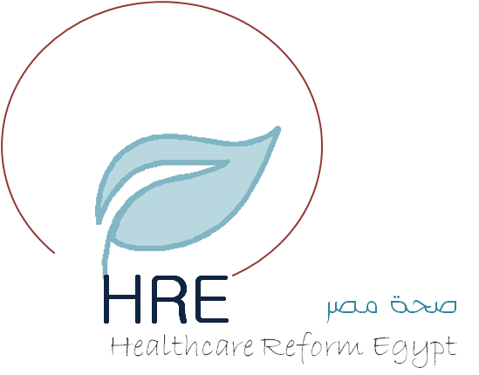
Applicant Group Information
Applicant groups are responsible for the implementation of the CSP in their locations in conformation with the program standards and details according to the HRE guidelines.
University or Hospital
Student Coordinator | Name: |  | Email address:  Cell Phone:
Names of student coordinator assistants (at least 2 students) | Name:  Email: |  | Name:  Email:
Name of Supervisor (Physician) | Name: |  | Cell Phone | Email
Any participating student clubs or organizations | Yes  No | Name of Organization: | Role in the program:
Volunteer Clinical Mentors (Hospital Mentors)
Hospital mentors will be asked to allow the clinical attachment of one medical student for 3 hours per week during their regular clinical time when they see patient. The total duration of the link is 12 weeks. They need to fill a feedback and evaluation of student progress and assign gradual tasks according to this progress.
Mentor Name | Department | Contact Phone | Email address
1
2
3
4
5
6

Mentor Name | Department | Contact Phone | Email address

